**Theory:**

**Programming Language: Python**

1. **Exponential Function using Iterative (Naive) Approach**

**Code:**

def power_iterative(*x*, *n*):

    result = 1

    for i in range(n):

        result *= x

    return result

print(power_iterative(2, 3))

**Output:**



**Space complexity:** O(1)

**Justification:** The algorithm uses only a fixed number of variables (result, x, n, and the loop counter), without any recursion or additional data structures. As a result, the space complexity remains constant at O(1) for all cases.

**Time complexity:**

**Best case time complexity:** O(1)

**Justification:** The best case occurs when n = 0. In this situation, the loop does not execute, and the function directly returns 1. This results in a constant-time operation with a time complexity of O(1).

**Worst case time complexity:** O(n)

**Justification:** The worst case occurs when n > 0. Here, the loop runs exactly n times, performing one multiplication per iteration. Therefore, the total number of operations grows linearly with n, giving a time complexity of O(n).

1. **Exponential Function with O(N) using Divide and Conquer Approach**

**Code:**

#t(n)=o(n)

def power(*x*,*n*):

    if n==0:

        return 1

    elif n%2==0:

        return power(x,n//2) * power(x,n//2)

    else:

        return x * power(x,n//2) * power(x,n//2)

print(power(2,3))

**Output:**

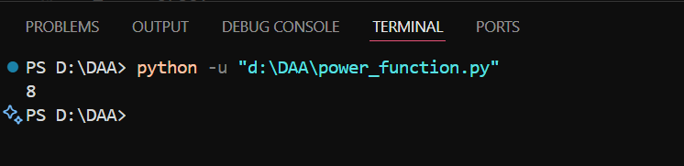

**Space complexity:** O(logn)

**Justification:** Each recursive call requires a separate location on the call stack when n > 0 in order to track variables and determine where to return once it is finished. It takes roughly log₂(n) steps to get to the base case because the function always reduces n by half. This indicates that the space complexity is O(log n), meaning that the call stack will never go deeper than roughly log₂(n) frames.

**Time complexity:**

**Best case time complexity:** O(1)

**Justification:** If it directly hit base case then it have O(1) time complexity

**Worst case time complexity:** O(n)

**Justification:** When n > 0, the function always makes two new recursive calls for the same half-sized problem, instead of saving and reusing the result. This means the work doubles at each step of the recursion. Even though the recursion only goes about log₂(n) levels deep, the total number of calls adds up quickly like 1 call, then 2 calls, then 4, then 8, and so on until it reaches roughly 2n calls. That’s why, instead of being fast like O(log n), it ends up taking O(n) time.

1. **Exponential Function with O(logN) using Divide and Conquer Approach**

Code:

*#t(n)=o(log n)*

*# Using recursion with optimized approach*

**def** power(*x*,*n*):

    temp**=**power(x,n**//**2)

**if** n**==**0:

**return** 1

**elif** n**%**2**==**0:

**return** temp **\*** temp

**else**:

**return** x **\*** temp **\*** temp

**print**(power(2,3))

Output:



**Space complexity:** O(logn)

**Justification:** Each recursive call requires a separate location on the call stack when n > 0 in order to track variables and determine where to return once it is finished. It takes roughly log₂(n) steps to get to the base case because the function always reduces n by half. This indicates that the space complexity is O(log n), meaning that the call stack will never go deeper than roughly log₂(n) frames.

**Time complexity:**

**Best case time complexity:** O(1)

**Justification:** If it directly hit base case then it have O(1) time complexity

**Worst case time complexity:** O(logn)

**Justification:** In the worst scenario, the function calls power(x, n//2) exactly once in each step when n > 0. Regardless of how big n is, it does a tiny, fixed amount of additional work after returning the recursive result just a few multiplications. It only takes roughly log₂(n) steps to get to the base case, where n = 0, because each recursive step cuts n in half. This indicates that the function's worst-case time complexity is O(log n), meaning that the total amount of work increases proportionately to log n.